**Existing System**

**Support Vector Machines**

Support Vector Machine (SVM) is a [**supervised machine learning**](https://www.geeksforgeeks.org/supervised-unsupervised-learning/) algorithm used for both classification and regression. Though we say regression problems as well it’s best suited for classification. The main objective of the SVM algorithm is to find the optimal [**hyperplane**](https://www.geeksforgeeks.org/separating-hyperplanes-in-svm/) in an N-dimensional space that can separate the data points in different classes in the feature space. The hyperplane tries that the margin between the closest points of different classes should be as maximum as possible. The dimension of the hyperplane depends upon the number of features. If the number of input features is two, then the hyperplane is just a line. If the number of input features is three, then the hyperplane becomes a 2-D plane. It becomes difficult to imagine when the number of features exceeds three.

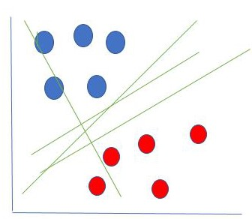

From the above picture we can see the hyperplanes dividing the Malicious Traffic from the Benign Traffic and then reroute the Malicious Traffic to not harm the server.